Amount Paid____________________50 AMP_____ 30 AMP ______ NA _____ SITE NUMBER___________

AMERICAN LEGION POST 500
RESERVED PARKING AGREEMENT
317-244-9625

2021 GENERAL NON-EVENT CAMPING FORM and AGREEMENT
PLEASE PRINT CLEARLY

NAME _______________________________________________________ PHONE: ______________________

E-MAIL ADDRESS___________________________________________________________________________ MAILING ADDRESS_________________________________________________________________________ CITY___________________________________________STATE____________ZIP CODE________________

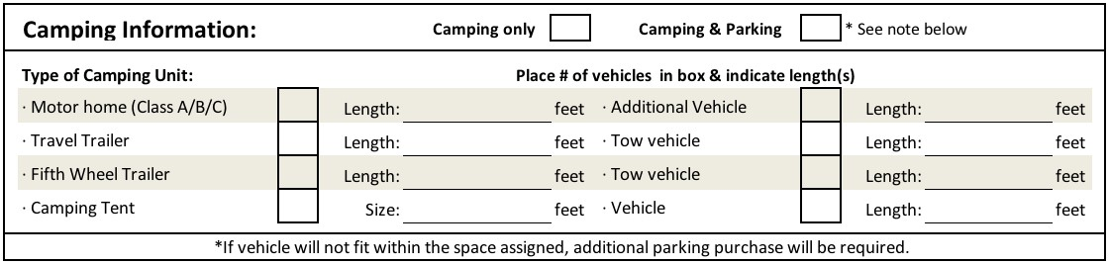
GENERAL NON-EVENT DAILY PARKING FEES
CAMPING WITHOUT ELECTRICITY | ________SPACE(S) $ 35.00 EACH
CAMPING WITH ELECTRICITY 30 AMP | ________SPACE(S) $ 45.00 EACH
CAMPING WITH ELECTRICITY 50 AMP | ________SPACE(S) $ 55.00 EACH
ARRIVAL DATE:__________________

DEPARTURE DATE:__________________

IF VEHICLE WILL NOT FIT WITHIN THE SPACE ASSIGNED,
ADDITIONAL PARKING PURCHASE WILL BE REQUIRED.

PLEASE READ AND SIGN THE REVERSE SIDE OF THIS FORM.

Page 1 of 2 Revised 10/17/2020

